1. Same concept as java inheritance. Also every java class inheritance from default class Object same every pom.xml also inherits from a super pom.xml file.  
   lets see the super pom.xml
2. Go to the maven installation directory. 
3. 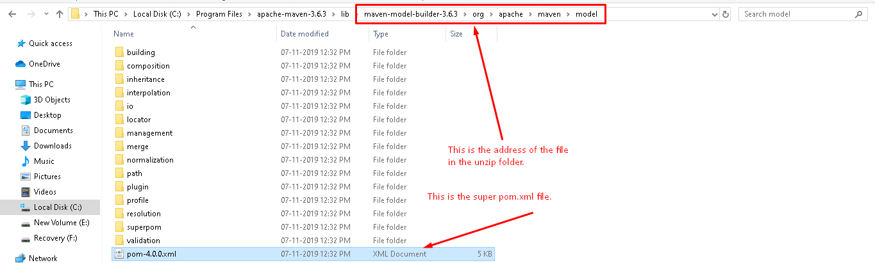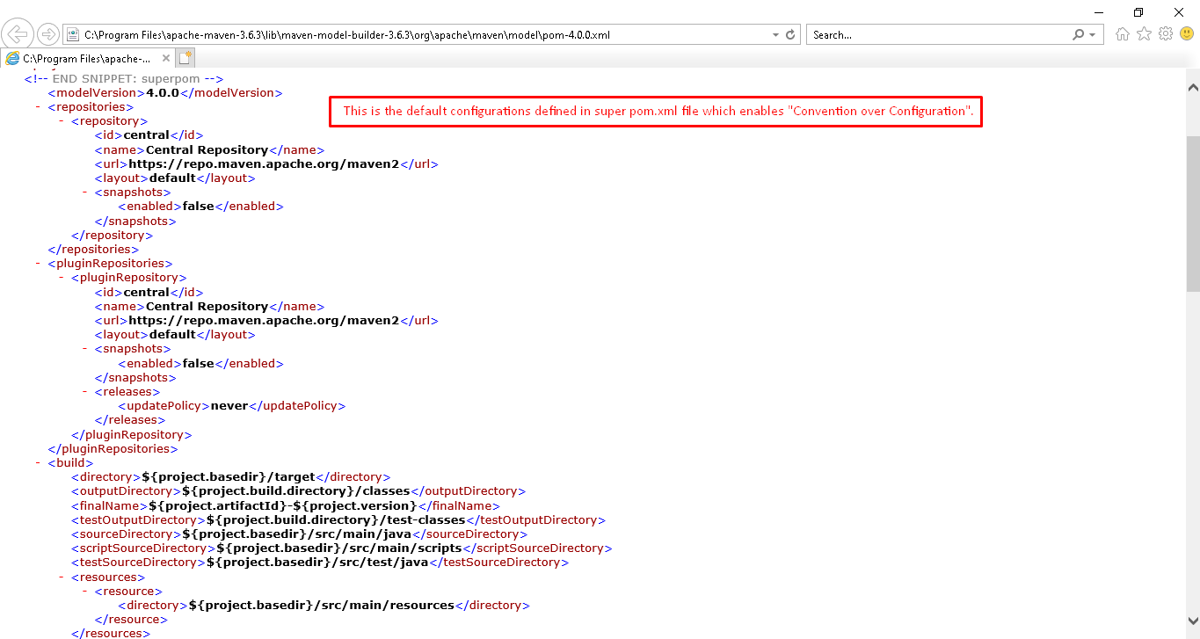
4. Command to print effective Pom.xml

Let’s define the Parent Pom and then inherit from it.

1. There are some steps to follow to create a pom.xml file to act as parent pom.xml file and another pom.xml file which would inherit the configuration from the parent pom.xml file.
2. Steps:
   1. Create maven project whose pom.xml file would act as parent. In the file,
      1. <**packaging**>pom</**packaging**>
      2. Define the default configurations.
      3. Run the command mvn install. This command does two things as I (Jatin) saw. Under m2/repository
         1. It stores the jar file of the project under m2/repository/groupId/actifactId/versionNo/arctifactId-versionNo.jar
         2. It stores the jar file of the project under m2/repository/groupId/actifactId/versionNo/arctifactId-versionNo.pom
   2. Create another maven project whose pom.xml would inherit from the parent
      1. Each maven project has its own <artifactId> as each project has its own unique name within the organization. So artifactId doesn’t inherit.
      2. Child pom.xml has <parent> tag which contains coordinates of the parent
         1. <parent> has the following tags for coordinates
            1. <artifactId>
            2. <groupId>
            3. <version>  
               All these three contains values from the parent pom fille.
3. 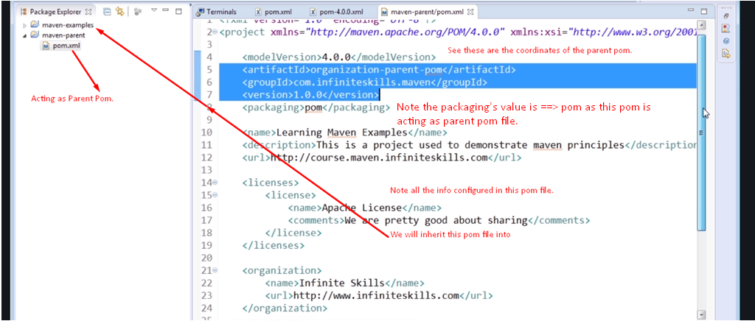
4. 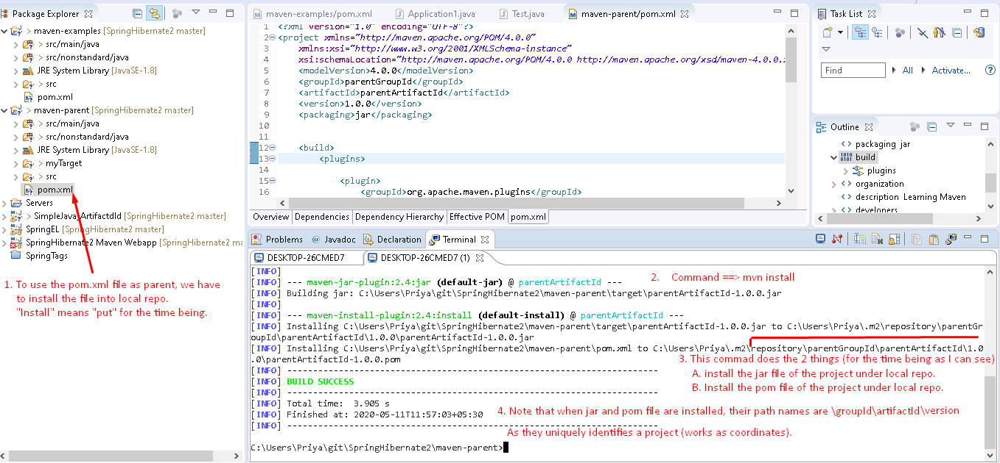
5. Till now we have installed the parent pom and jar files into the local repository
6. Now, Inherit the parent into child pom.
7. 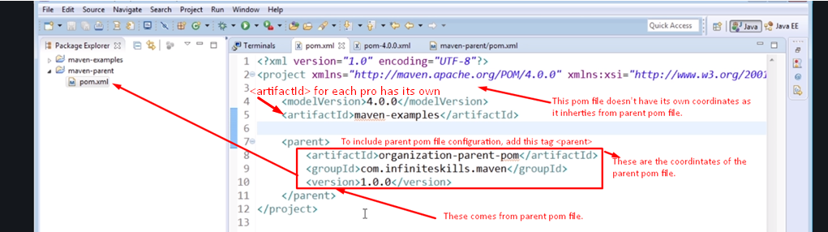
8. 